Title: | Assignment 5: ETL Processing and Data Processing with Python
Special Notes / Additional Resources: | - A template to submit screenshots showing completion of your assignment is available for download with this assignment.
Submission Requirements (4 files required)

- The submission template containing your screenshots.
- Screen shot from SSMS of the created tables
- Python program for processing 3 csv files using one level of data staging
- Extract from target table from your database

Analysis and Design/Staging of Data [15 Marks]

Overview
- As a data scientist, you have been tasked to assemble data required for analyzing North American data around crop yields, fertilizer and pesticide use for three commodities: barley; rye; and wheat for years 1961 - 2018.

- The goal of this exercise is to perform the upfront data analysis and design and develop a program that will create load and integrate data from 3 csv files provided by www.ourworldindata.org.
Source Data
There are three data files used in this assignment. Review the CSV files included with this assignment from www.ourworldindata.org. Files have header rows describing the content.
cropyield.csv yield in tonnes by hectare
fertilizers.csv fertilizer use in kg by hectare
pesticide-use-per-hectare-of-cropland.csv pesticide use in kg by hectare.

- Note: the data in each data set can be joined by Entity and Year fields.
- Note: treat fields with zero and blank fields as null.

Focus of Study
- Only barley, rye and wheat commodities are part of the study for North America (Canada, United States and Mexico).
- The actual yield for a given crop will need to be calculated from the yield in tonnes by hectare source file using commodity attainable field and commodity yield gap field,
  - i.e. barley_actual_yield = barley_attainable – barley_yield_gap
Hint: you will need a field to capture this calculated value by each commodity
Target Table
- The target table combines data from all three source files.
- The BarleyActualYield, RyeActualYield, WheatActualYield, FertilizerKgHa and PesticideKgHa fields will be summarized by decade.
- The decade field will be represented by the last two digits of the decade (e.g., 60 represents 1960 – 1969).
- If any of the input data set is incomplete for a decade, i.e. PesticideKgHa is missing for a year in the decade, set the IncompleteWarning flag to “Y” else leave “N”.
- Your target table should have the following design (note the compound primary key on CountryCode and Decade)
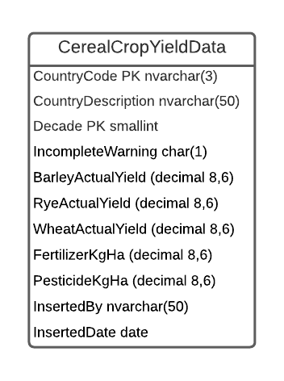
Staging Requirements: Single Level of Staging
- With the source and target data defined, the staging table(s) will need to be defined to support loading your source data as you deem necessary.
- Use one level of data staging and incorporate inserted by and insertion date/timestamp audit columns in your design.
Hint: filter out un-needed data as soon as possible

General Program Requirements
- Create an ETL Python program to process the required source data into the target table
- You can create one or more programs to implement the requirements as you see fit.
Along with your code, you are required to prepare and submit a flow chart describing the logic of your program(s).
- Within your program(s), create a fruitful function for calculating actual yield (actual yield = attainable – yield gap) that is used.
- Make use of a Python list which contains the crop
- Complete the following template for data transformations:
Source File | Source Field | Staging Table | Staging Field | Staging Transformation(s) | Target Table | Target Field
Note: there will be no source for calculated fields.
- Create the necessary tables within a SQL Server database. Note: an existing database or new database can be created in your MS SQL Server instance.

Instructions/Requirements
[10 marks] Submit a flowchart on the design of an ETL program(s) to extract, transform and load the three csv files. Identify when and where you filtered out unnecessary rows and where you preformed the necessary calculations. The flowchart does not need to include the creation of the tables in the database. The design will incorporate a fruitful function to calculate the actual yield of any commodity and another fruitful function to summarize the data by decade. Include a screenshot of your data mapping transformations template filled out.
[25 marks ] Submit a copy of your Python ETL program used to extract, transform and load the data from the 3 source csv files to the CerealCropYieldData target table in your database.
From SSMS, extract your CerealCropYieldData rows into a csv format. This can be done by right clicking on the table in SSMS and “Select Top 1000 Rows”.
From the results tab right click on a cell, “Select All” and “Save Results As”.

